Caregivers Who Need a Break May Drop Off Their Loved One

Families Are Also Welcome to Attend as a Group

Care Provided in a Christian Environment

Volunteers Trained by Professionals with the REST Program

Volunteers Also Have Basic CPR/First Aid Certification Through the American Red Cross

The afternoon was so nice," said Betsy, whose daughter, Lisa, attended a drop-off respite event at Calvary Lutheran Church, Wood Dale, Ill.

"Lisa enjoyed the activities and the attention she received from everyone, especially the teens who took the time to talk with her and help her feel welcome and accepted."

The congregation began its respite-care ministry after members went through REST training. Among those who completed the course: four "Teen Buddies."

The congregation looks forward to seeing its respite ministry grow, said Dawn Leardi, director of Christian education. "It's a lot of work, but we are excited about the task ahead of us."
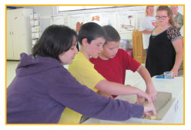
Lisa, left, enjoys a hands-on Bible lesson with REST-trained
"Teen Buddies."
Reprinted with permission from “The Companion,” REST newsletter, Winter 2015-2016
Brochure Copyright @ January 2016

Respite Care Program

Calvary Evangelical Lutheran Church
(Lutheran Church – Missouri Synod)

Providing Care for Your Loved One in a Christian Environment

107 N. Wood Dale Road Wood Dale, IL 60191 (630) 766-2838 calvaree@sbcglobal.net www.calvarywooddale.net www.facebook.com/ calvarylutheranwooddale

Information About Calvary
Calvary Evangelical Lutheran Church has been serving the community of Wood Dale for 75 years. We support area organizations such as the Wood Dale Food Pantry, the K-9 Comfort Dogs of Lutheran Church Charities and Care Net Pregnancy Services of DuPage in their efforts to improve the quality of life for citizens of the community. We follow the teachings of Jesus in the Gospel of Matthew to feed and clothe the needy and to welcome strangers into our midst.

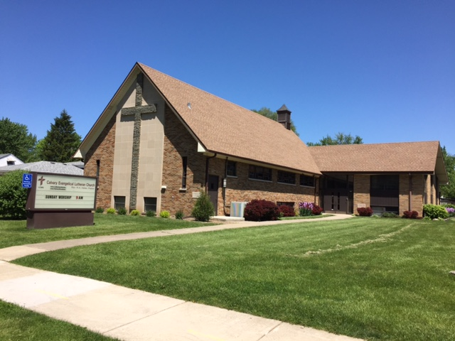

Our Respite Care Ministry
There are many families in our community who provide full-time care to a loved one. We know that all caregivers need a break from their responsibilities in order to refresh their hearts and minds. Our church would like to support those caregivers by welcoming their loved ones into our church home for a few hours.
Our volunteers have been trained by REST (Respite Education and Support Tools) professionals in strategies and techniques for engaging with and caring for individuals with special needs. These include individuals with cognitive and developmental disabilities as well as autism spectrum conditions. For more information about REST, please visit www.restprogram.org. Our volunteers are also certified in CPR and basic first aid.

Services Available
Calvary offers drop-off respite care events every other month on a Saturday afternoon. We will provide lunch and structured activities to keep your loved one engaged and active for a few hours.
We also offer an inclusive family chapel service every other month on a Sunday afternoon. This allows families an opportunity to worship in a simple church setting and enjoy a time of fellowship after the service.
Finally, we offer inclusive Christian education classes on Sunday mornings during the school year and an inclusive evening Vacation Bible School for one week over the summer.
Pre-registration is required for these activities. Please visit our website, e-mail or call us to obtain registration forms.

